Experiment VIII

**Aim**: Develop an operator precedence parser for a given language.

Algorithm

1. Start
2. Create the operator precedence table for the following operators: ‘+’, ‘-’, ‘*’, ‘/’, ‘(‘ and ‘)’.
3. Enter the string that needs to be processed.
4. Concat the string with the symbol ‘$’ at the end.
5. Shift the first symbol into the stack.
6. Repeat step 7 till ‘$’ is encountered in the input string.
7. If the expression can be reduced, reduce it. Else shift.
8. If the top symbol of the stack is the start symbol, print “string accepted”. Else print “string not accepted”.

Output

Enter the string: i + i

STACK INPUT ACTION

$i $ Shift

$E $ Reduced: E->i

$E$ Shift

$E$ Shift

String accepted

Screenshot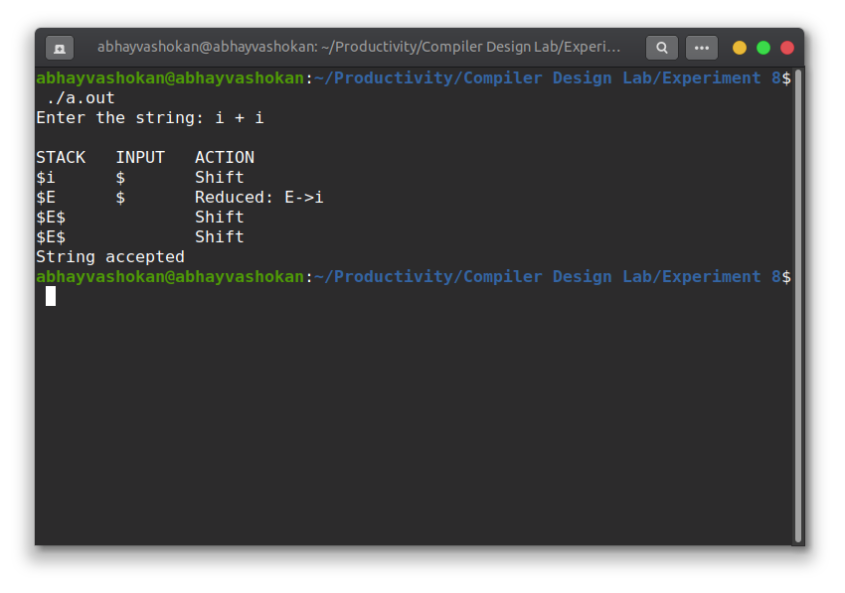

Readme

1. Compile and run the C program using the command

**gcc 2Abhay-P8.c && ./a.out**

2. Enter the string

3. The parser operation and the message whether the string is accepted or not is obtained as output.

**Result**: Successfully implemented a program to demonstrate operator precedence.